# Convert Data using Google Refine

**Prerequisite:**

1. Download Google Refine from: <https://github.com/OpenRefine/OpenRefine/releases/download/2.5/google-refine-2.5-r2407.zip>
2. Download Google Refine RDF Extension from:

<https://github.com/downloads/fadmaa/grefine-rdf-extension/grefine-rdf-extension-0.8.0.zip>

1. Extract Google Refine into local directory which we will refer as ***[Google Refine Directory]***

Example: ***D:\Tools\GRefine***

1. Extract the extension into ***[Google Refine Directory]/webapp/extensions***

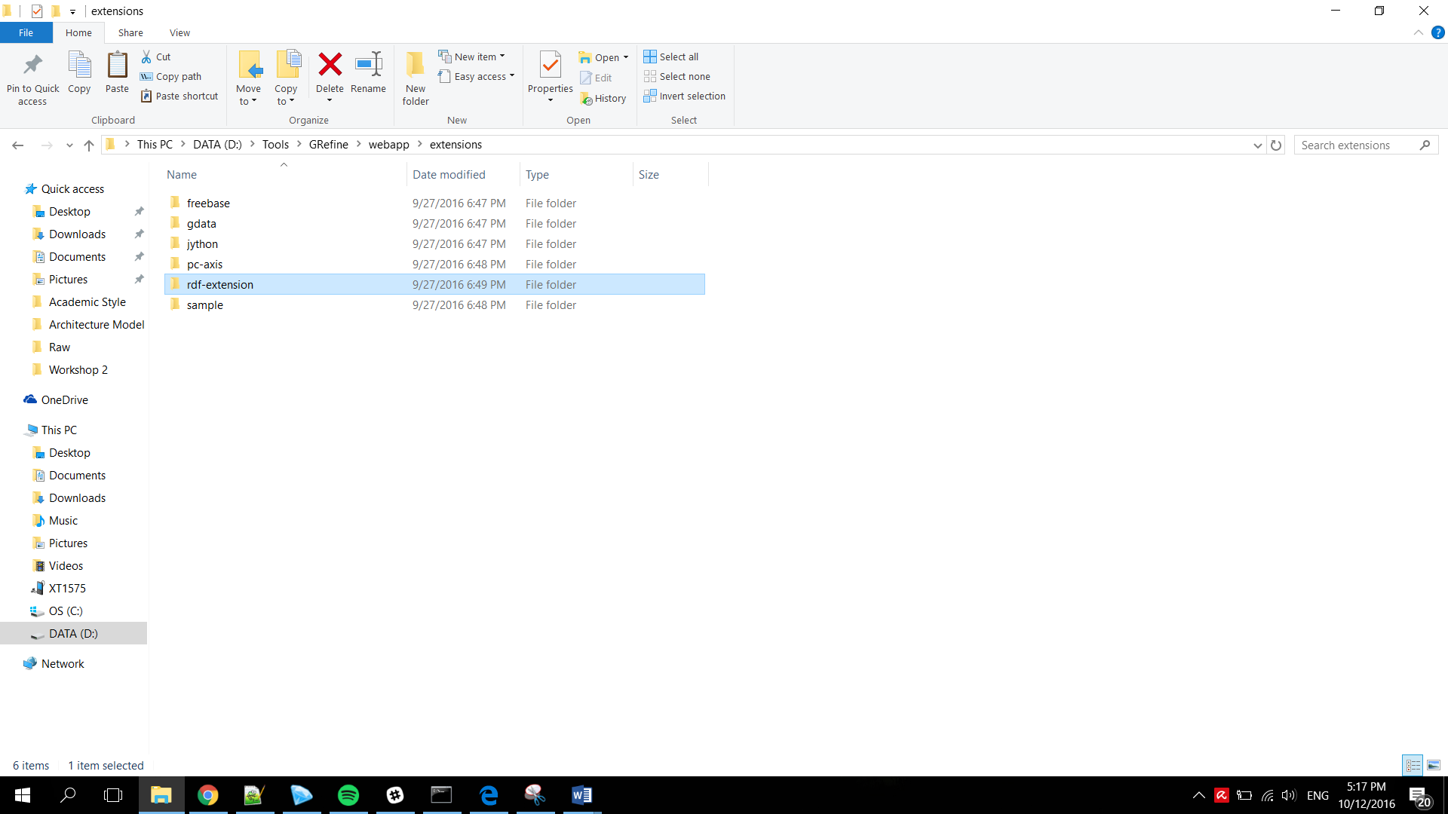

## Convert CSV to RDF in Google Refine

1. Start Google Refine Application from ***Google Refine Directory***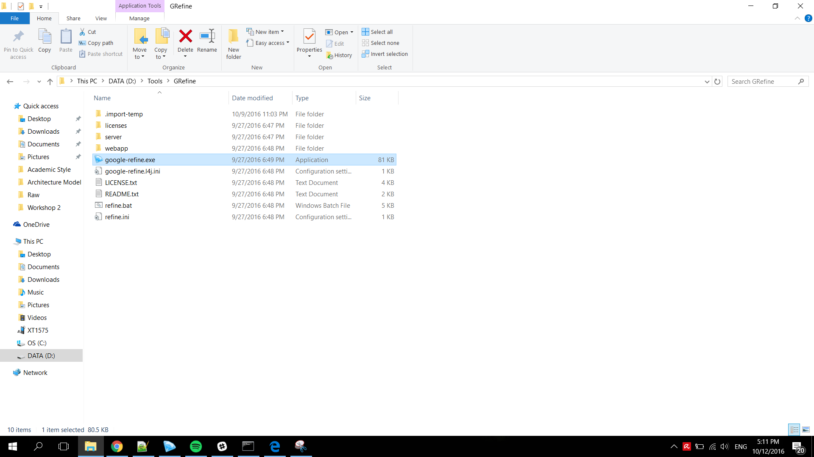
2. Google Refine started and you can access the application from your localhost in this URL: <http://127.0.0.1:3333/>

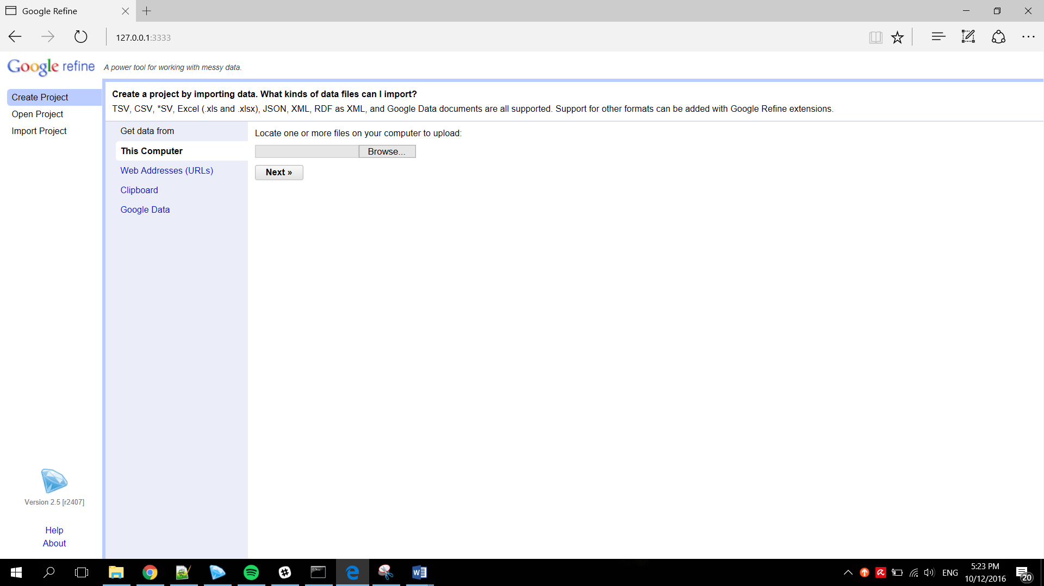

1. Create new project by uploading your data (TSV, CSV, *SV, Excel (.xls and .xlsx), JSON, XML, RDF as XML, and Google Data documents are all supported)

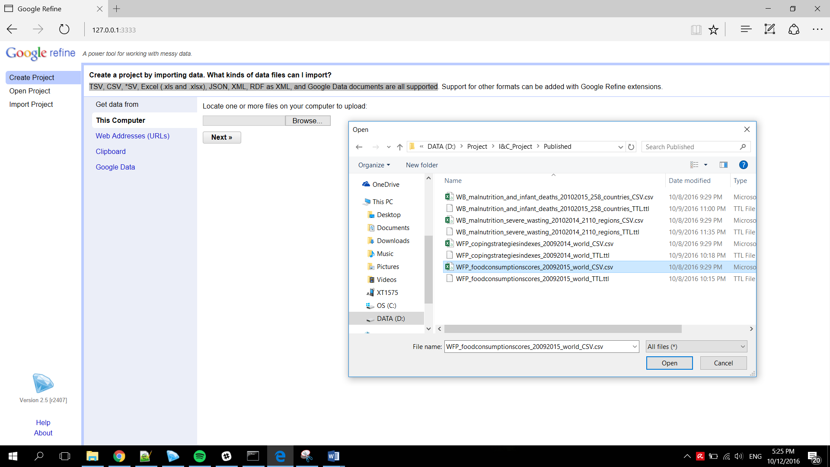

1. Configure the project parsing rules and create project (Google Refine represents the data in an intuitive way)

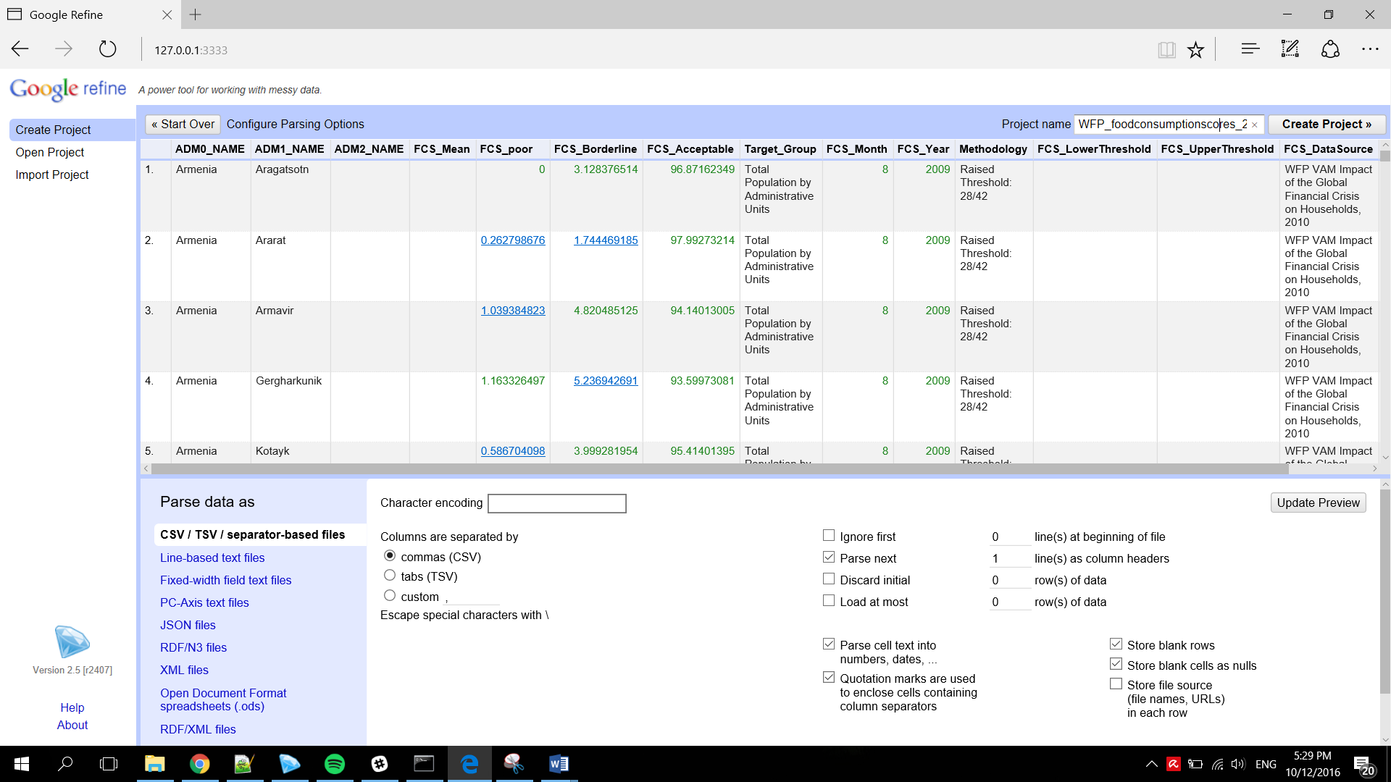

1. After the project created, define the RDF by using **Edit RDF Skeleton** function

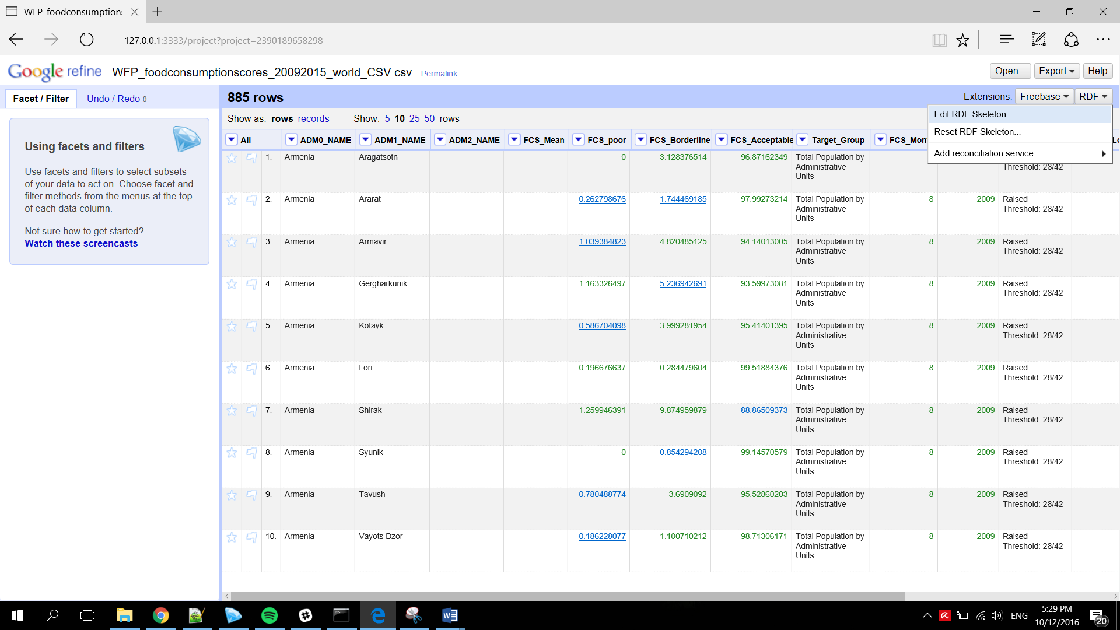

1. Define the ontology by using **add prefix** function

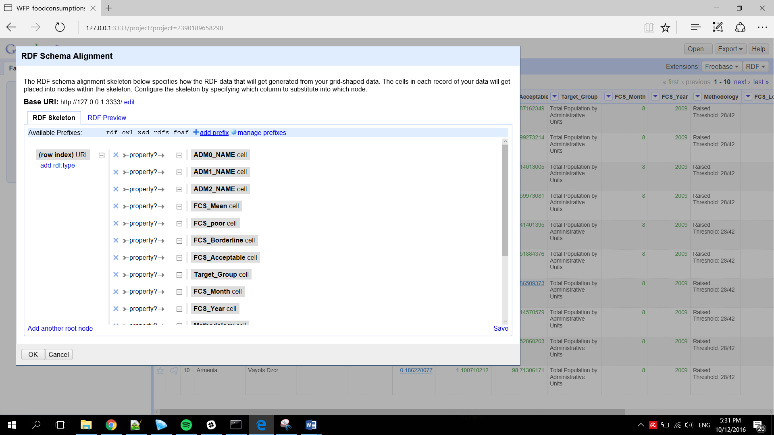

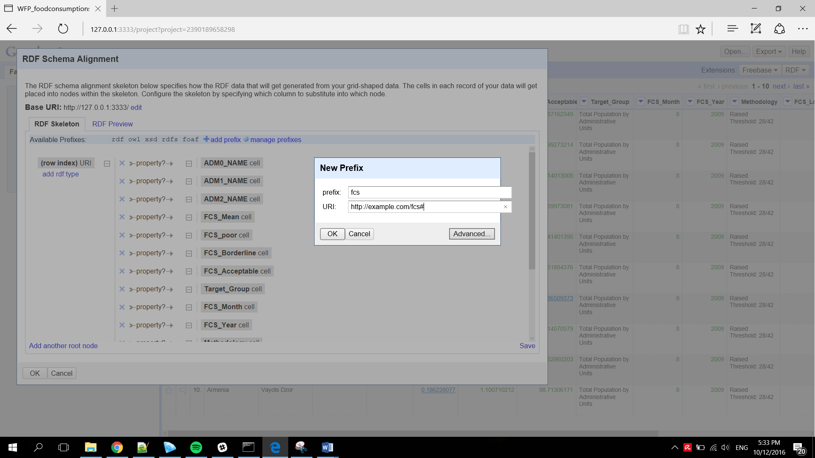

1. Define cell property using the prefix that have been added

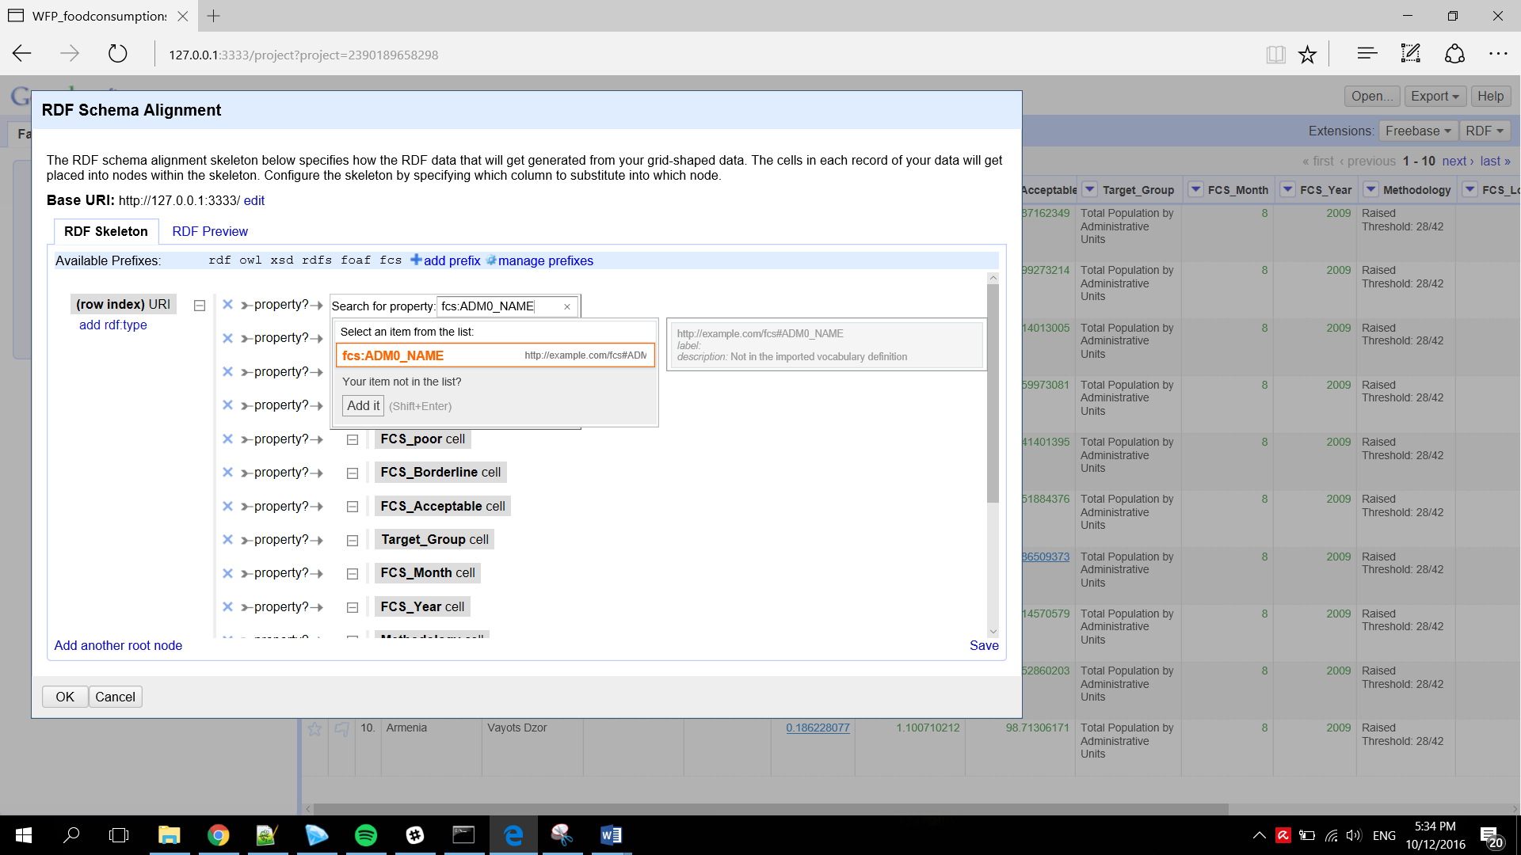

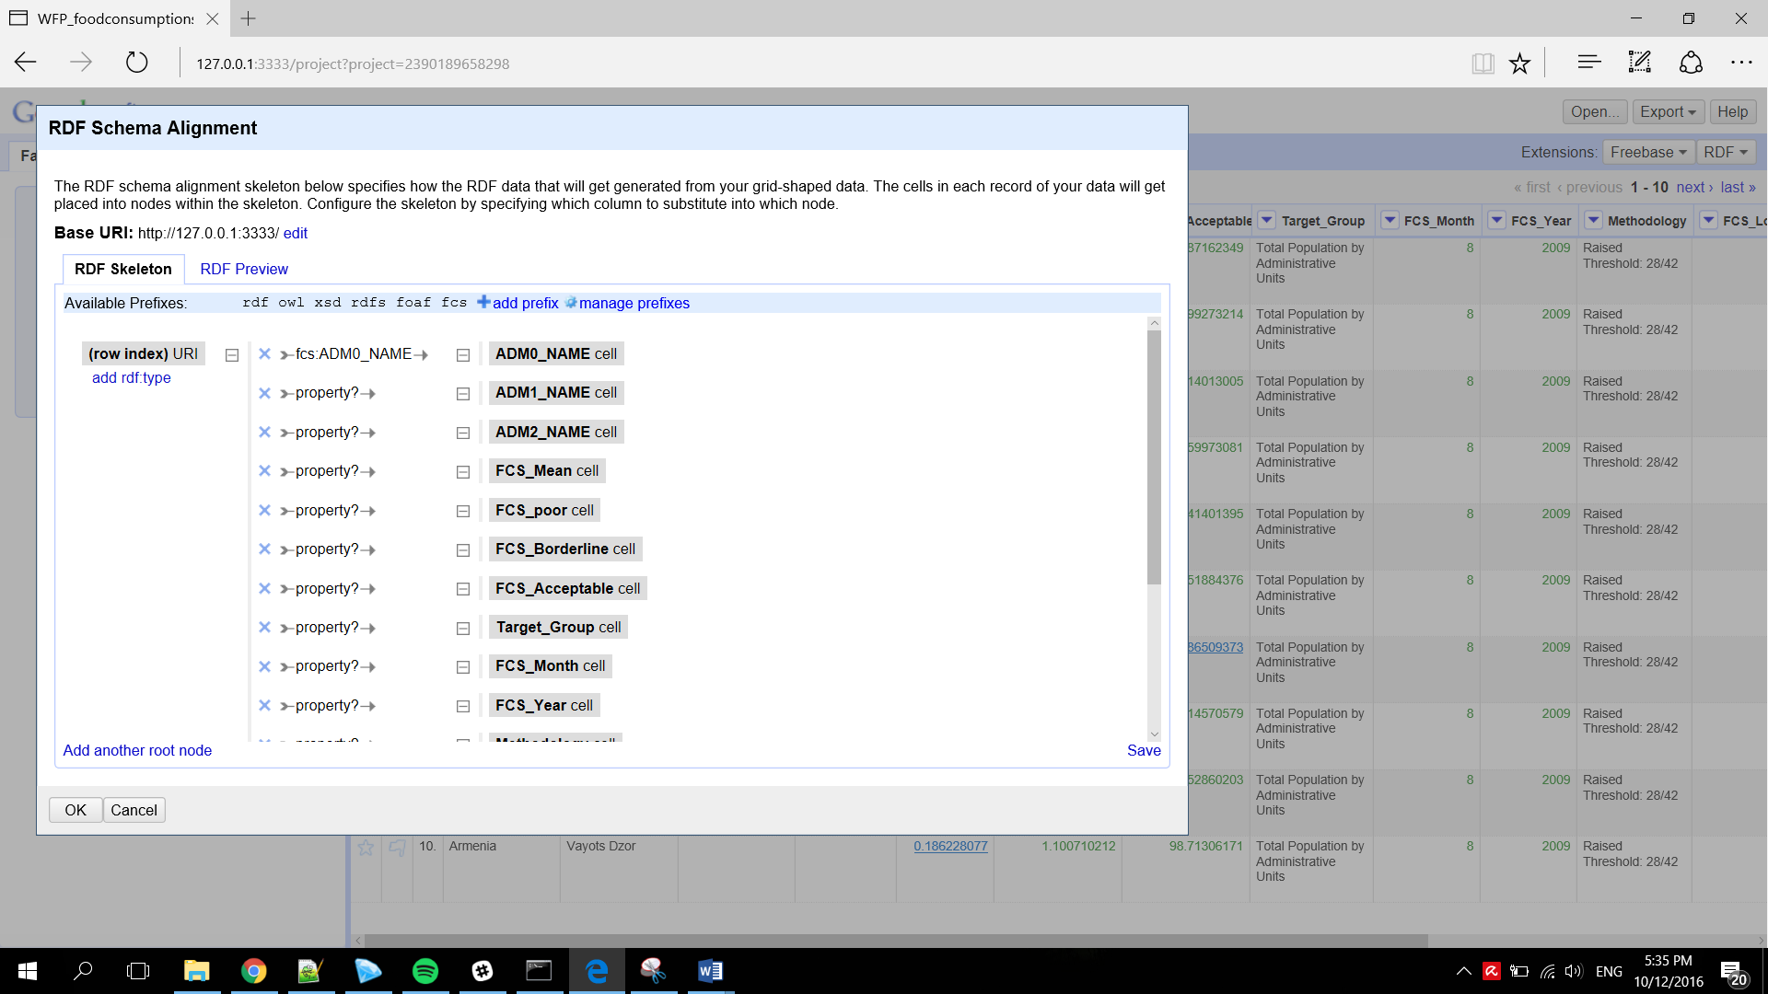

1. Define cell data type

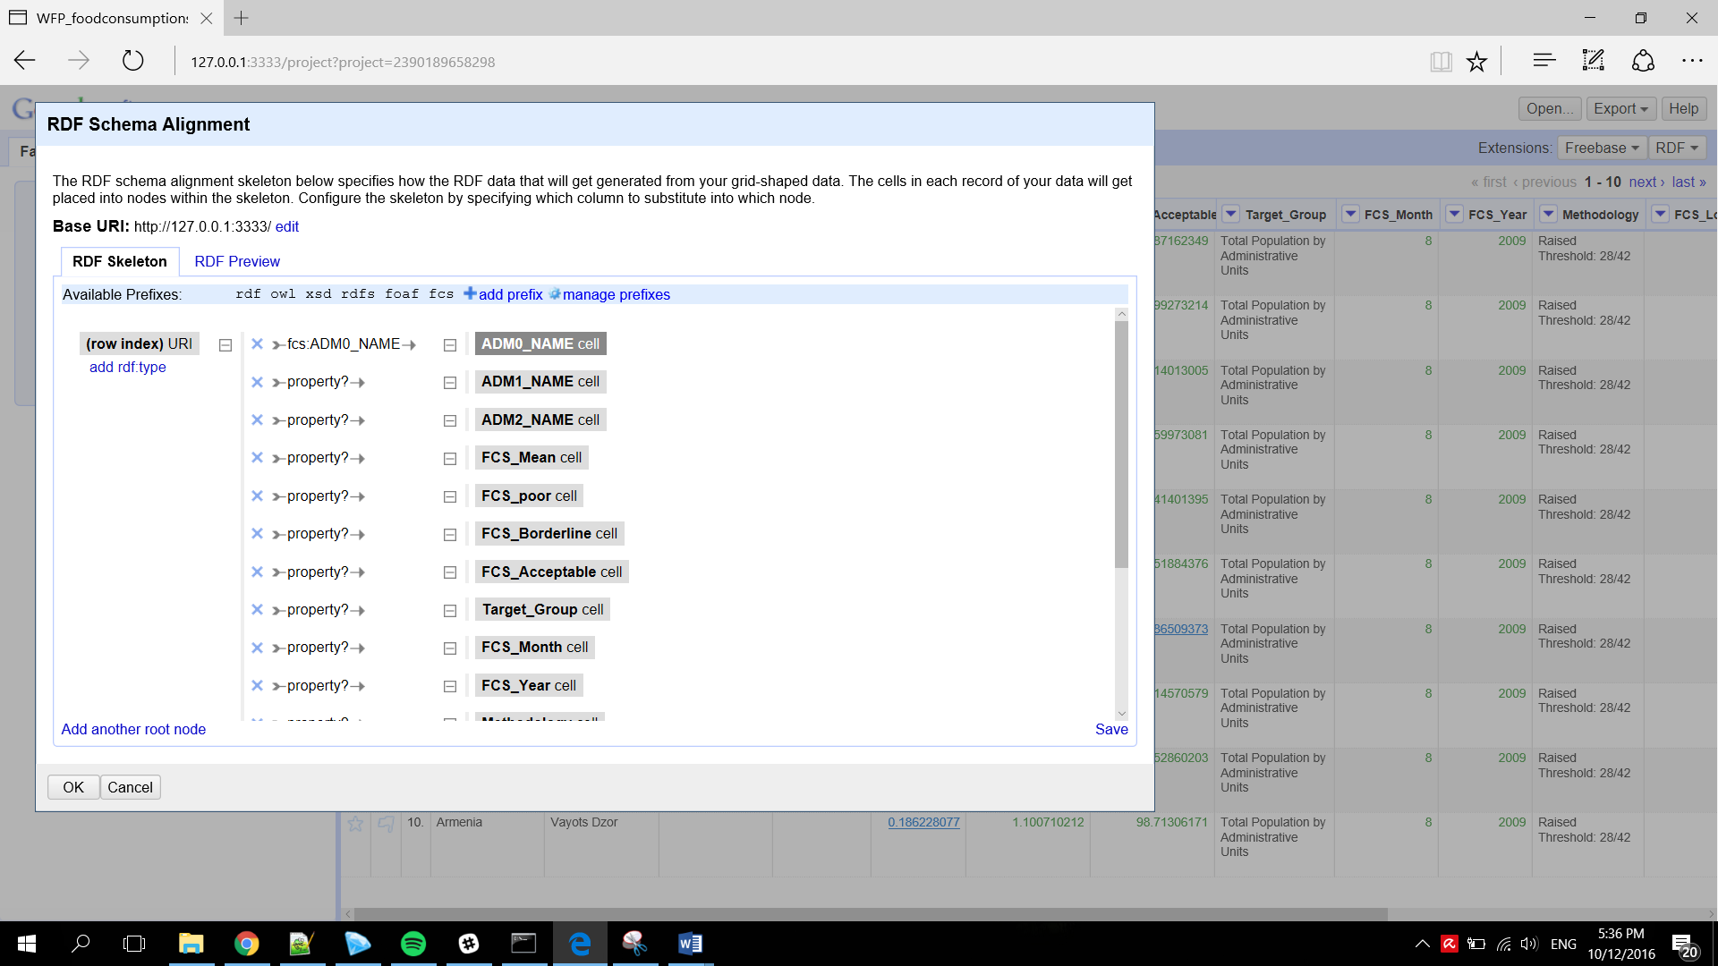

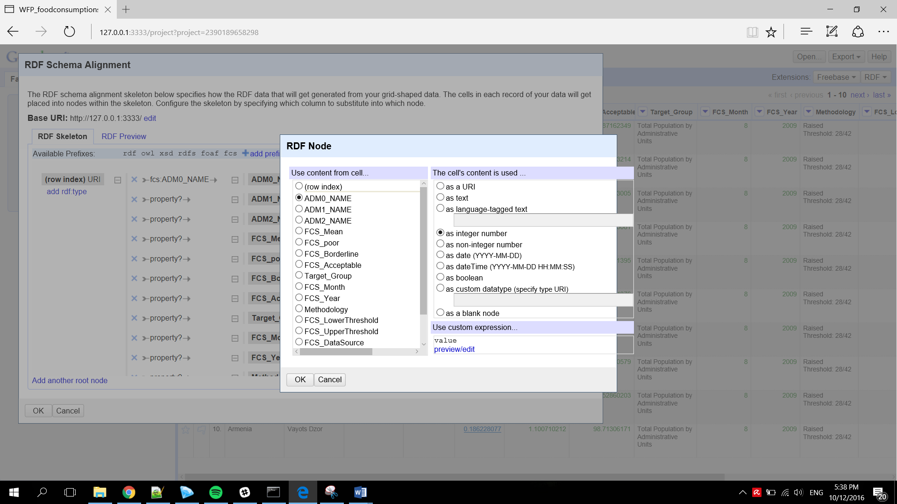

1. Preview RDF data that you have been created

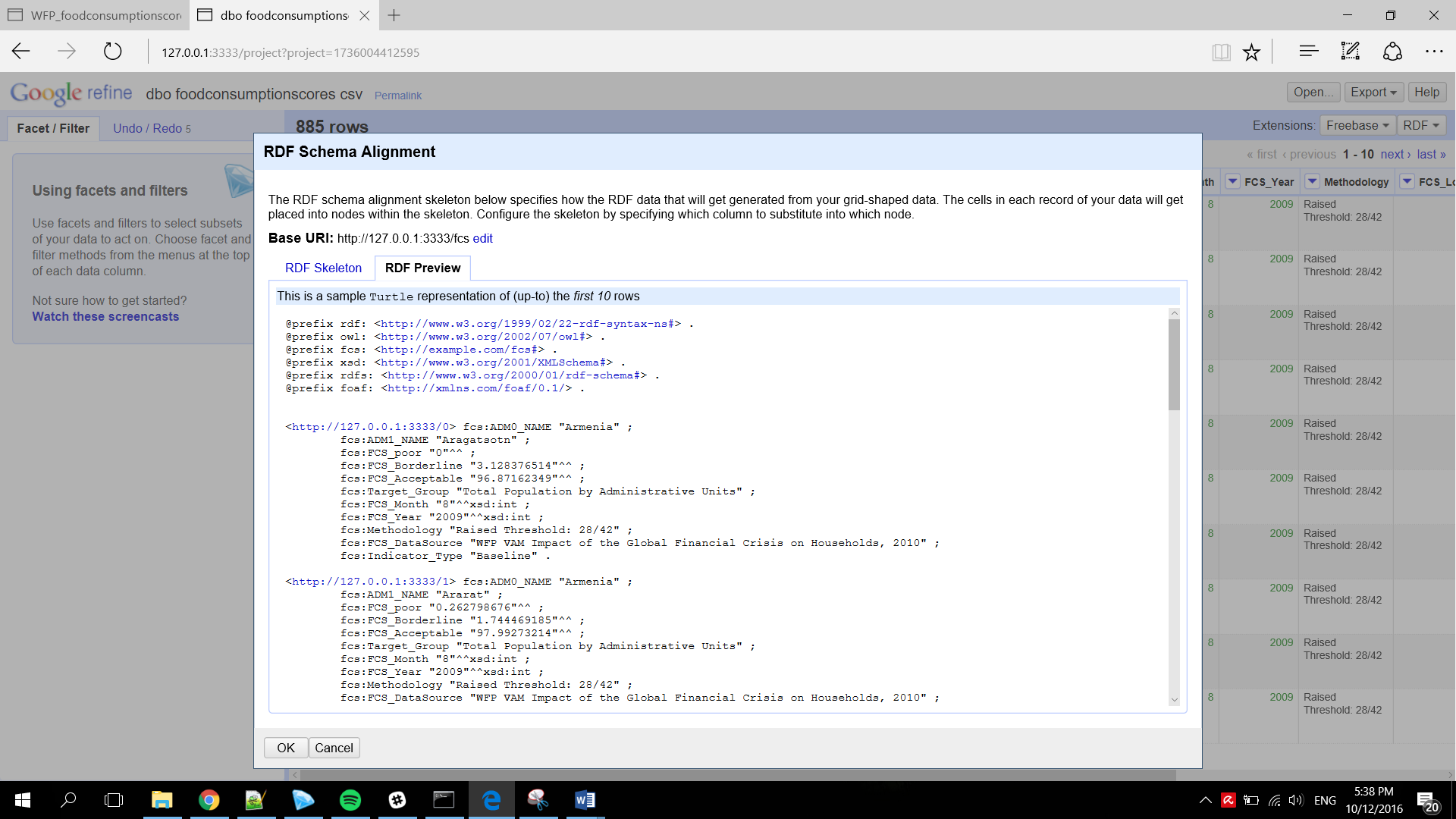

1. Export RDF into format that can be used by OpenCube Toolkit (Turtle/XML)

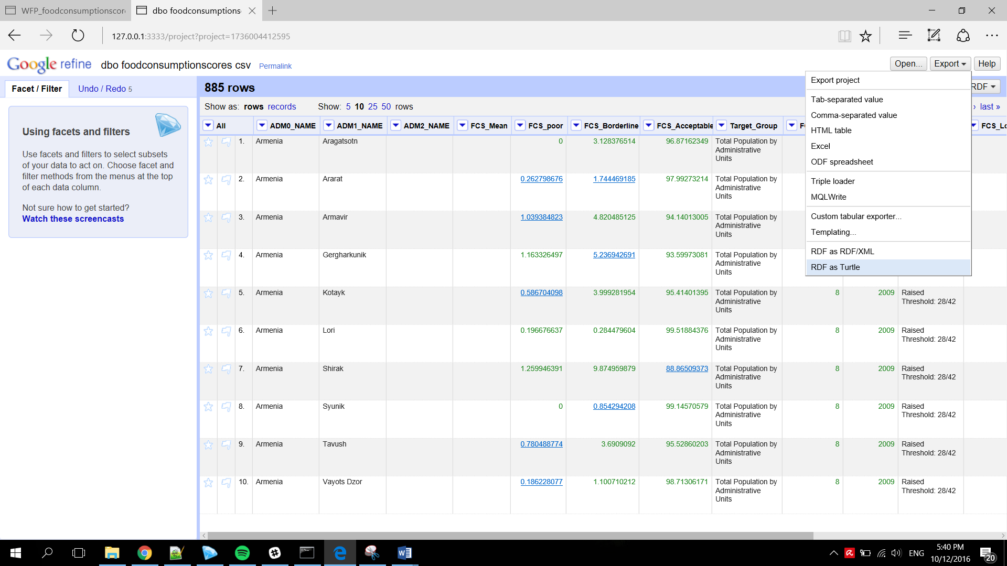

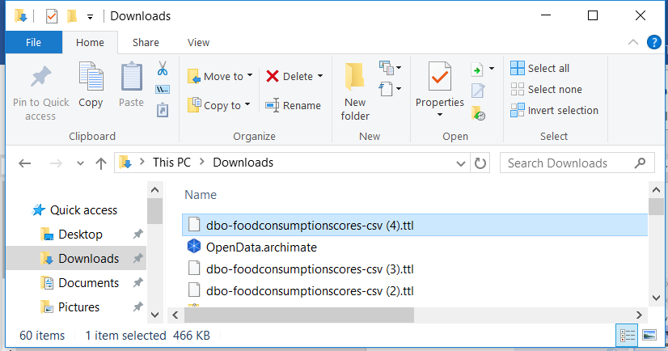

## Using RDF data from Google Refine in OpenCube Toolkit

### Data Import way:

1. Access Data Import function on OpenCube Toolkit Admin Page

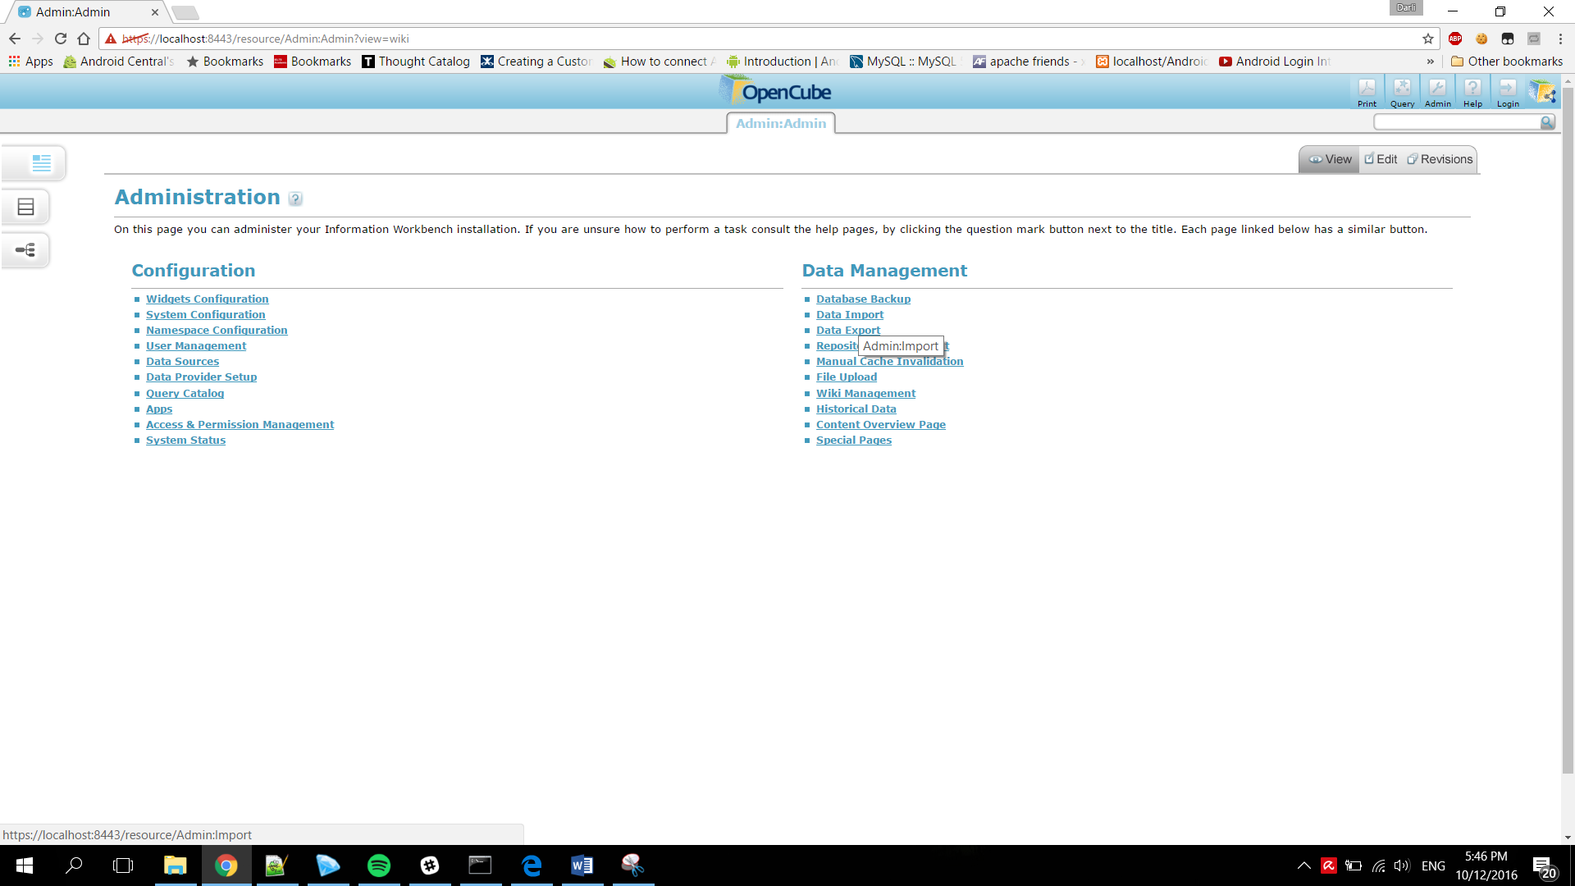

1. Choose Data Source>File>Source File

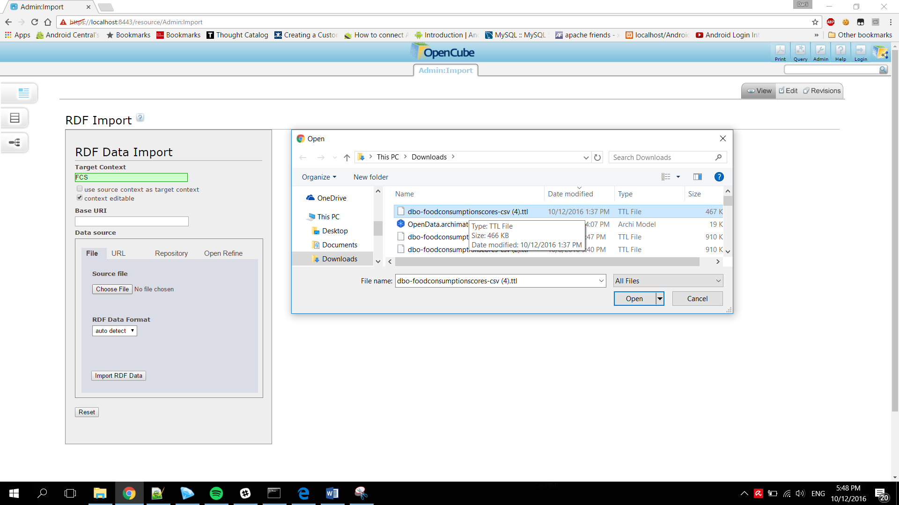

Alternative way using **Open Refine Import**

* Choose Data Source>Open Refine

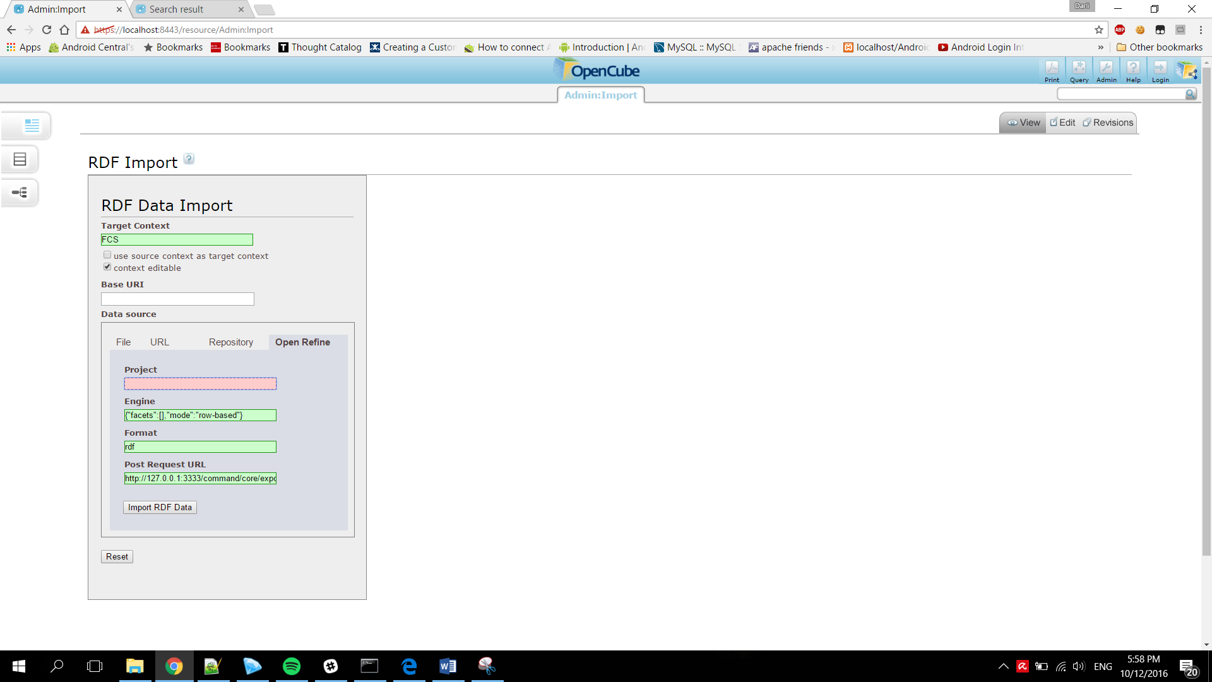

* Add project number from Google Refine into Project Field

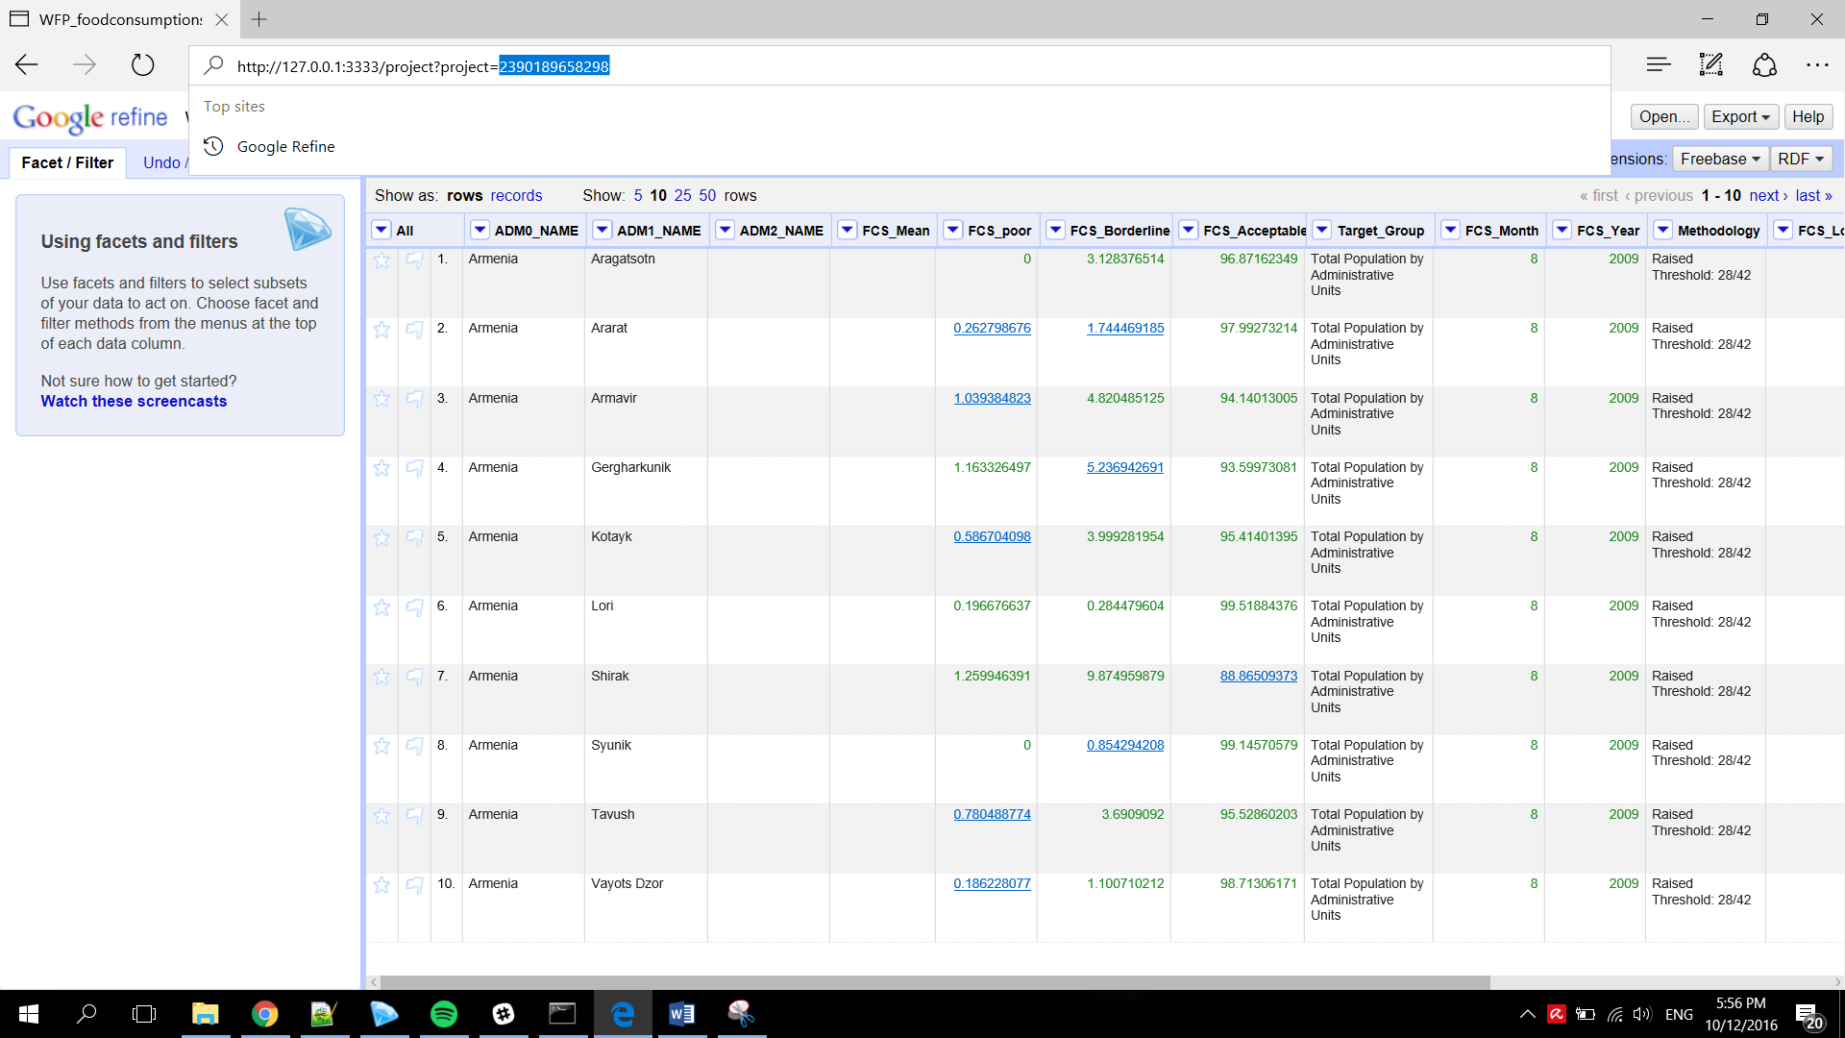

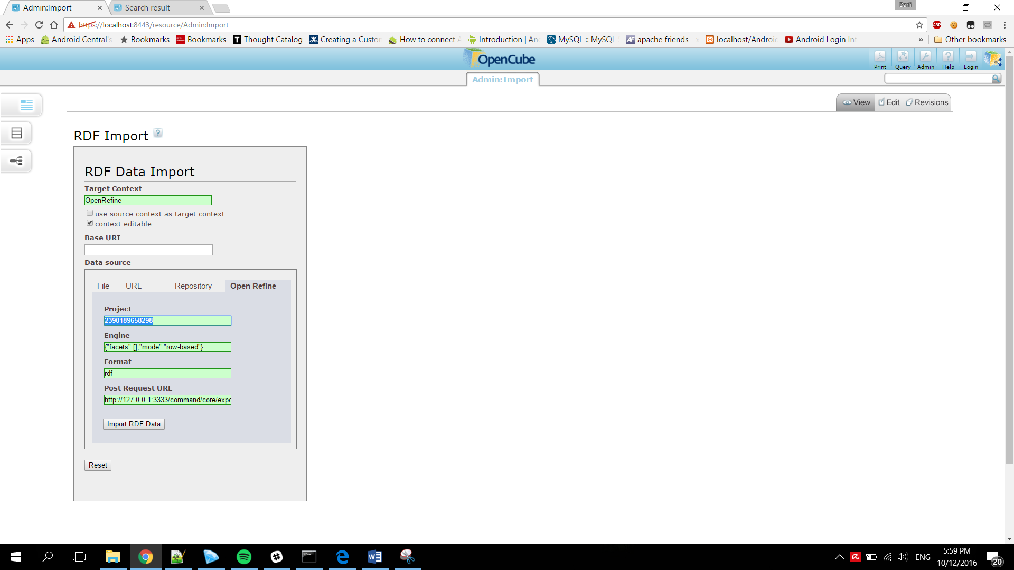

* Import RDF Data

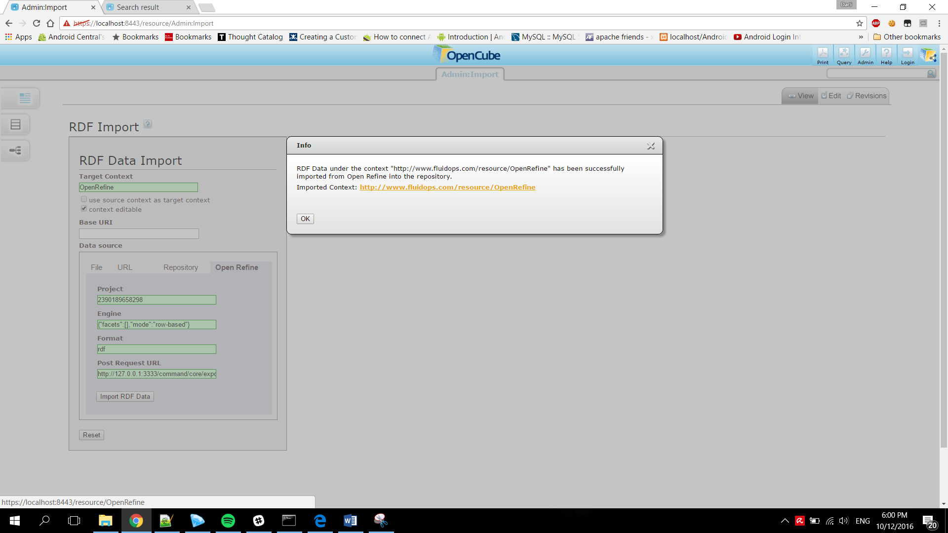

1. Import RDF Data

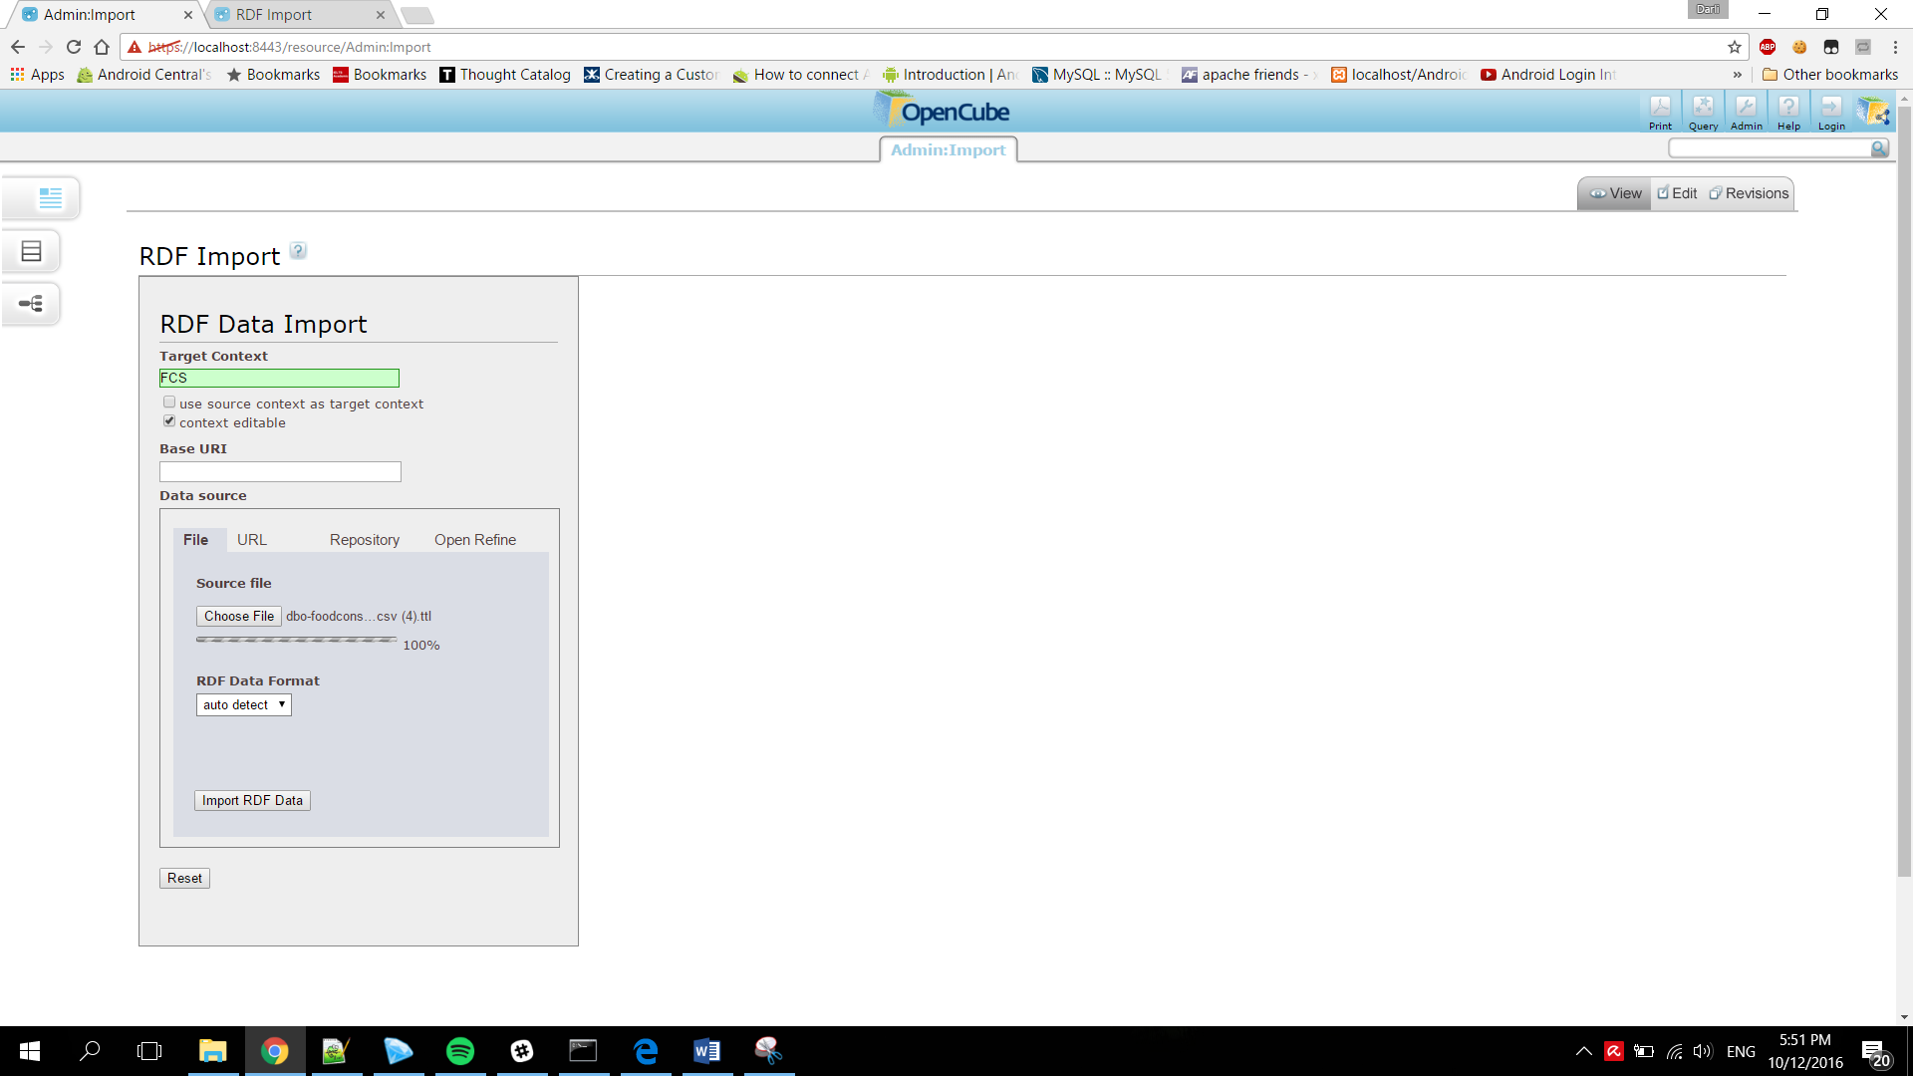

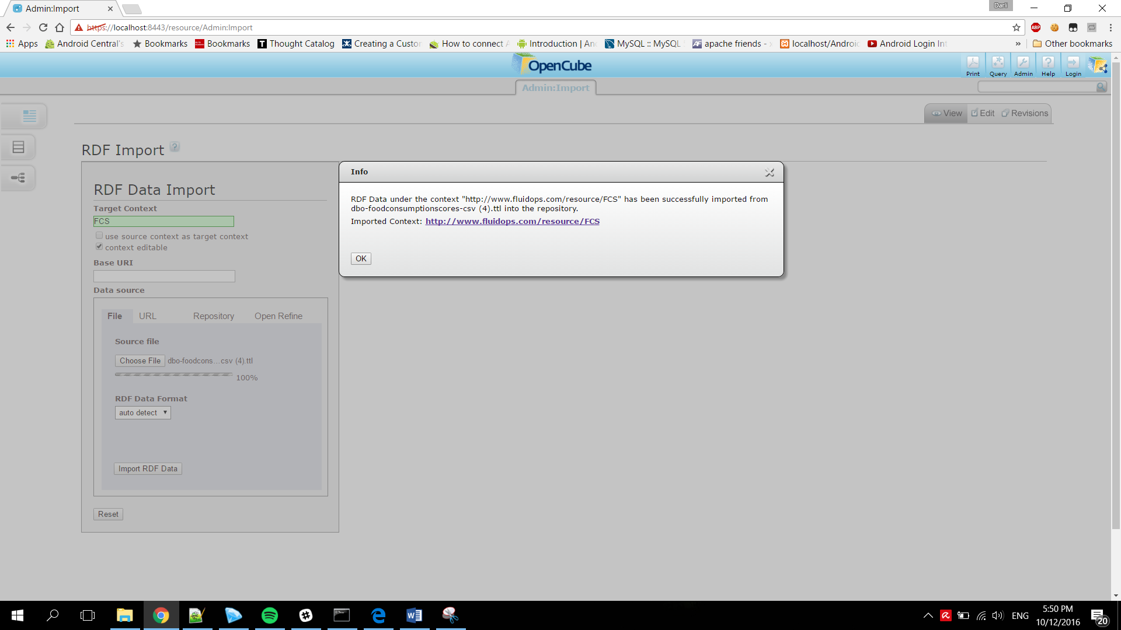

1. Access the RDF data imported through the link

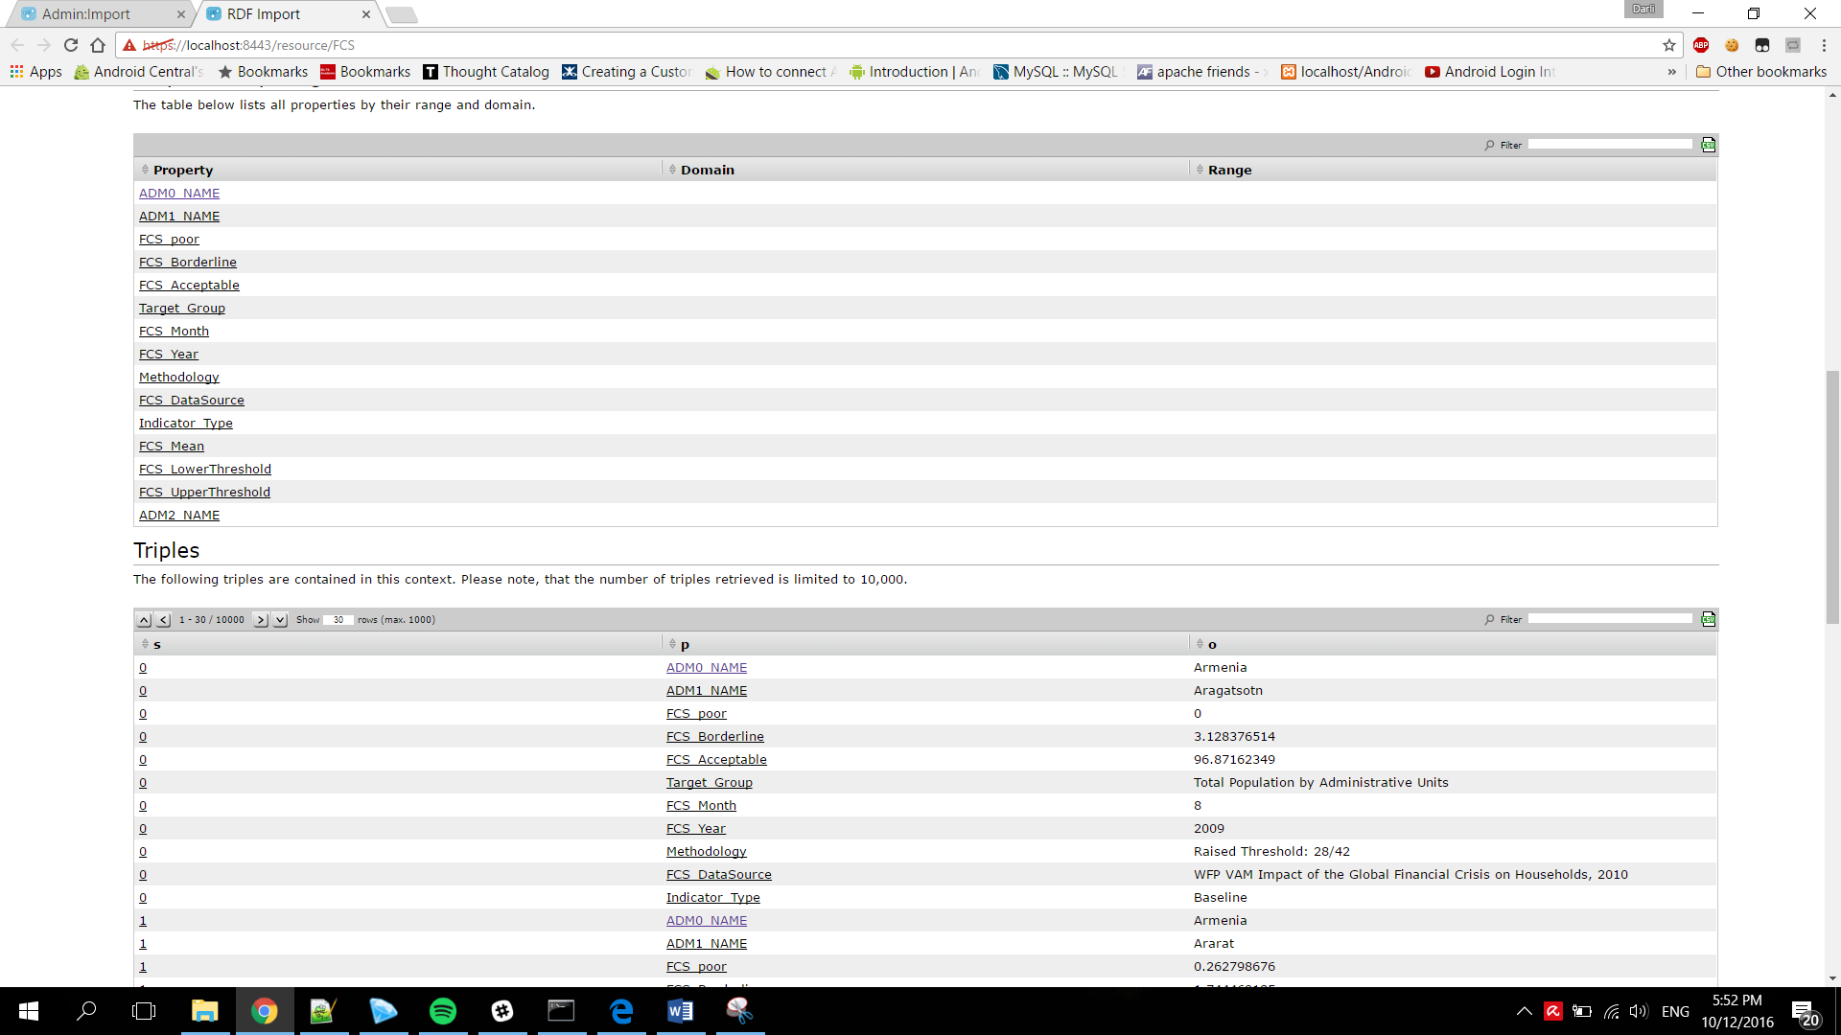

1. Try to query the data based on RDF Definition

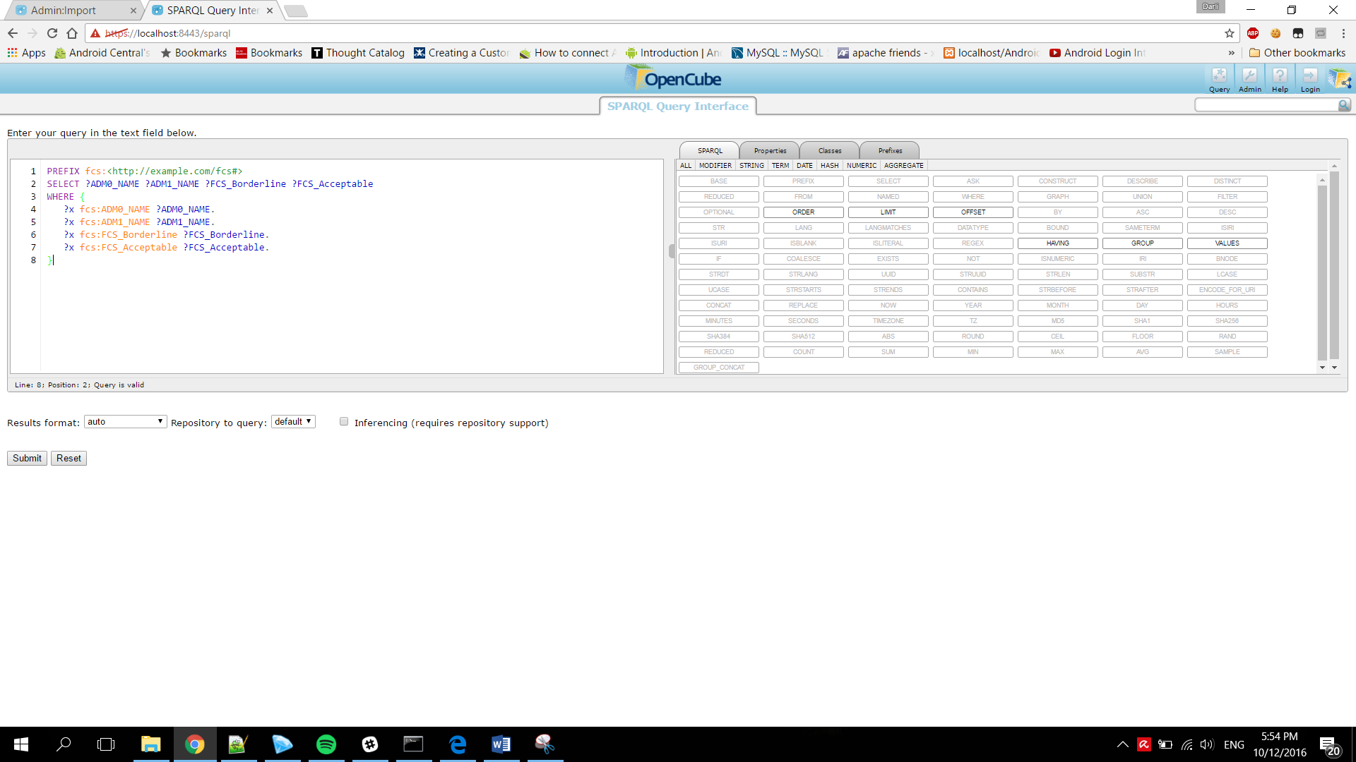

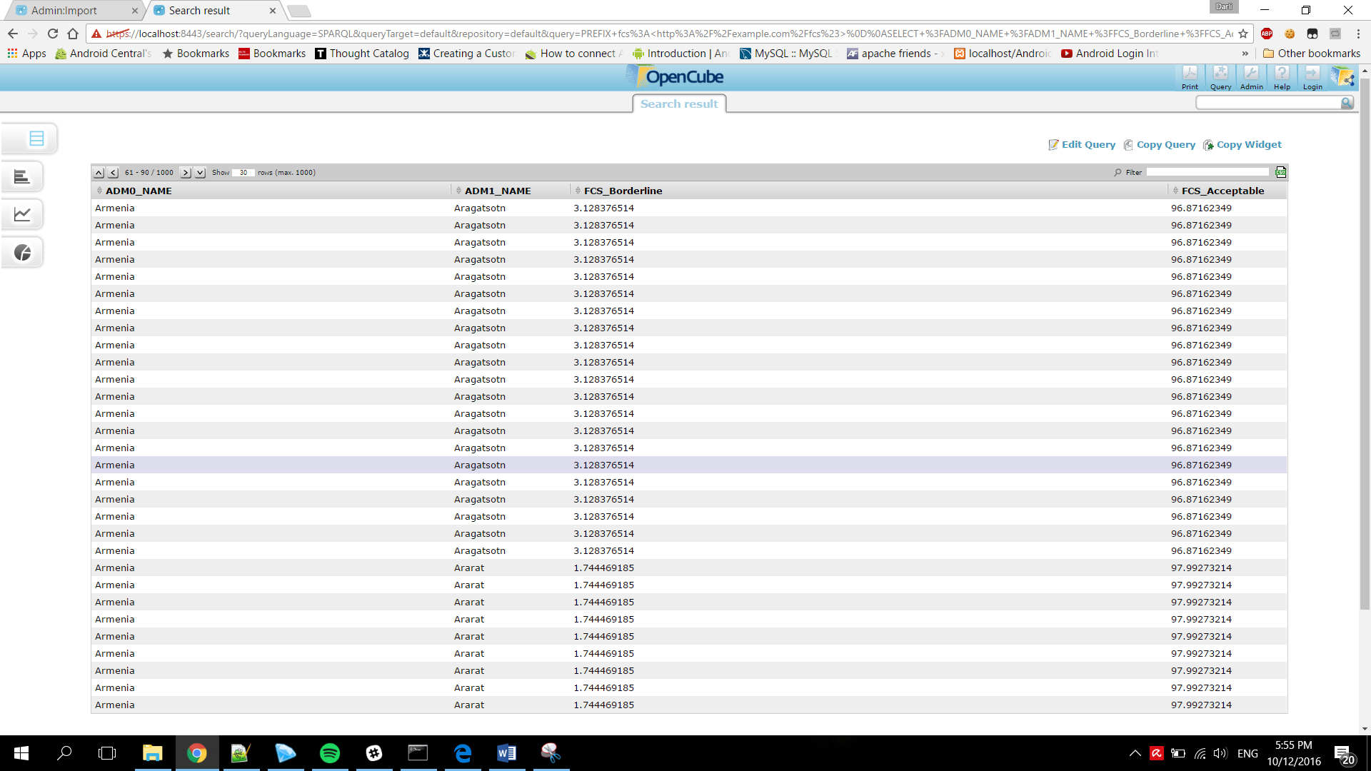

### Data Source way:

1. Access Data Source function on OpenCube Toolkit Admin Page

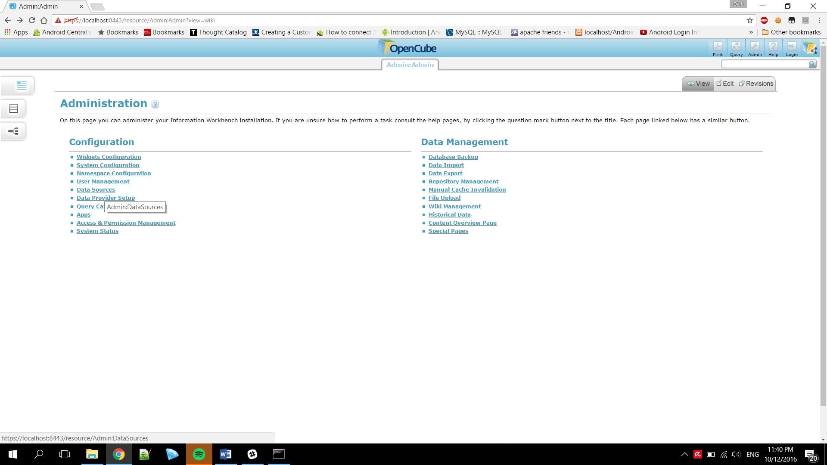

1. Click Create New Datasource

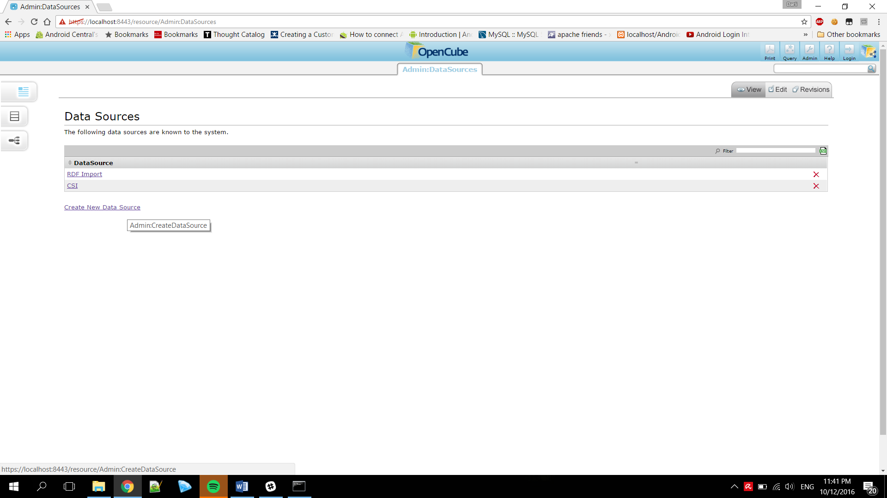

1. Fill the details and choose RDF file to be loaded

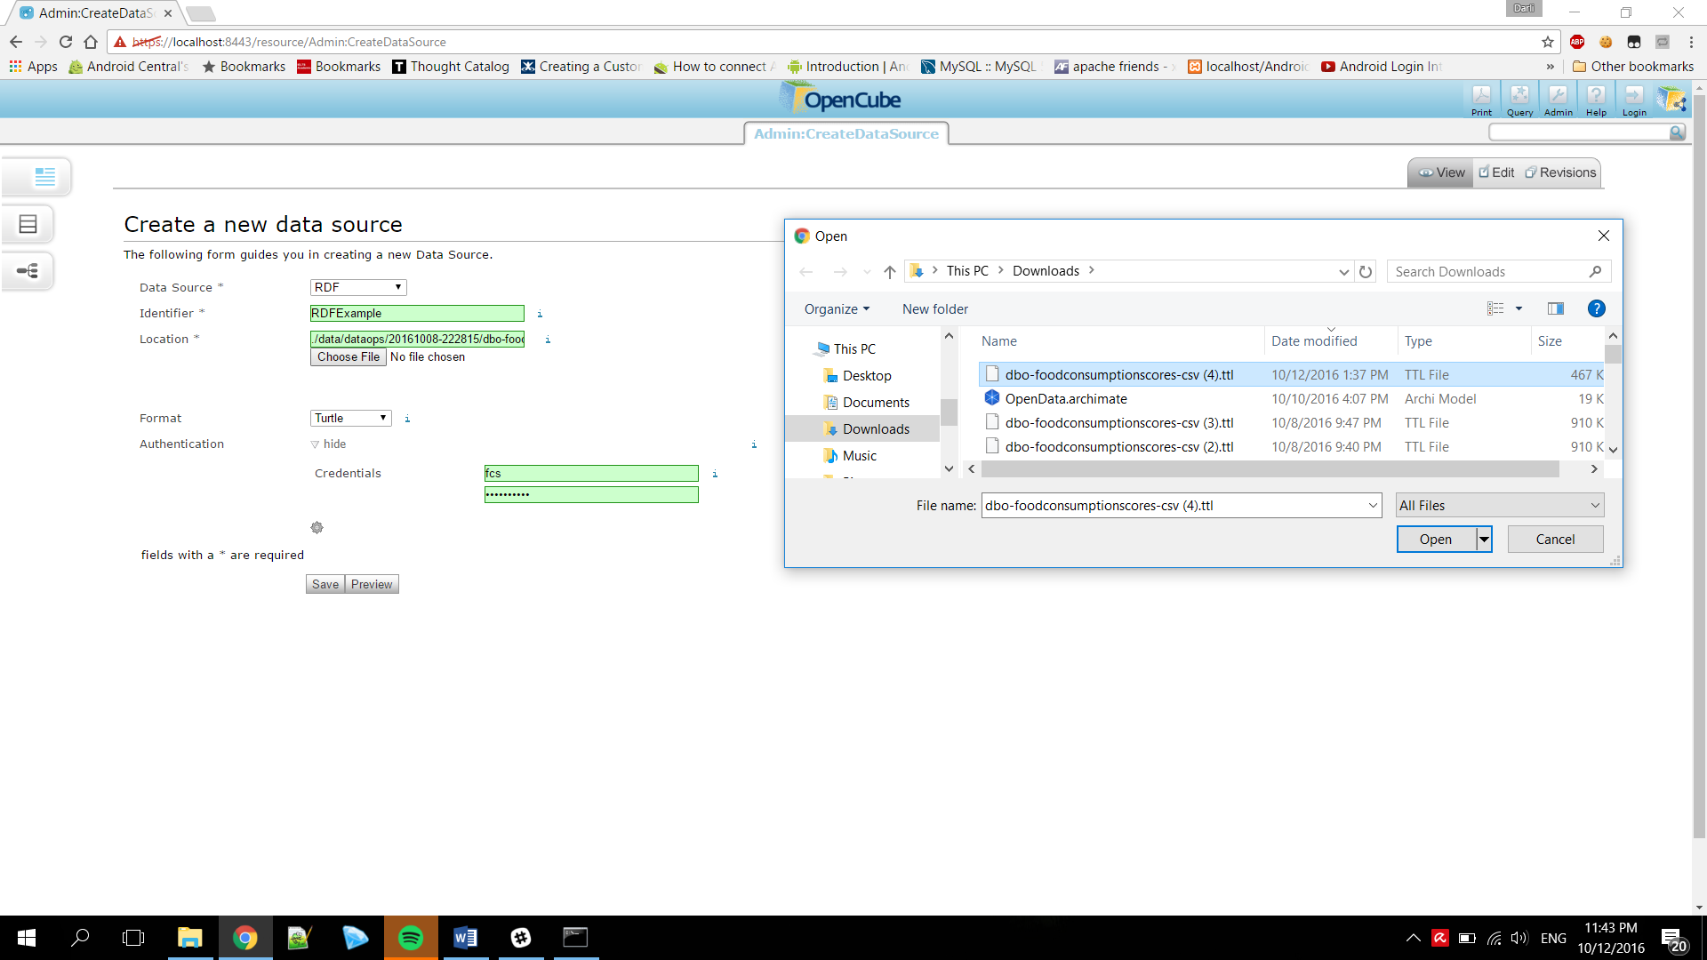

1. Preview the data and save the data source

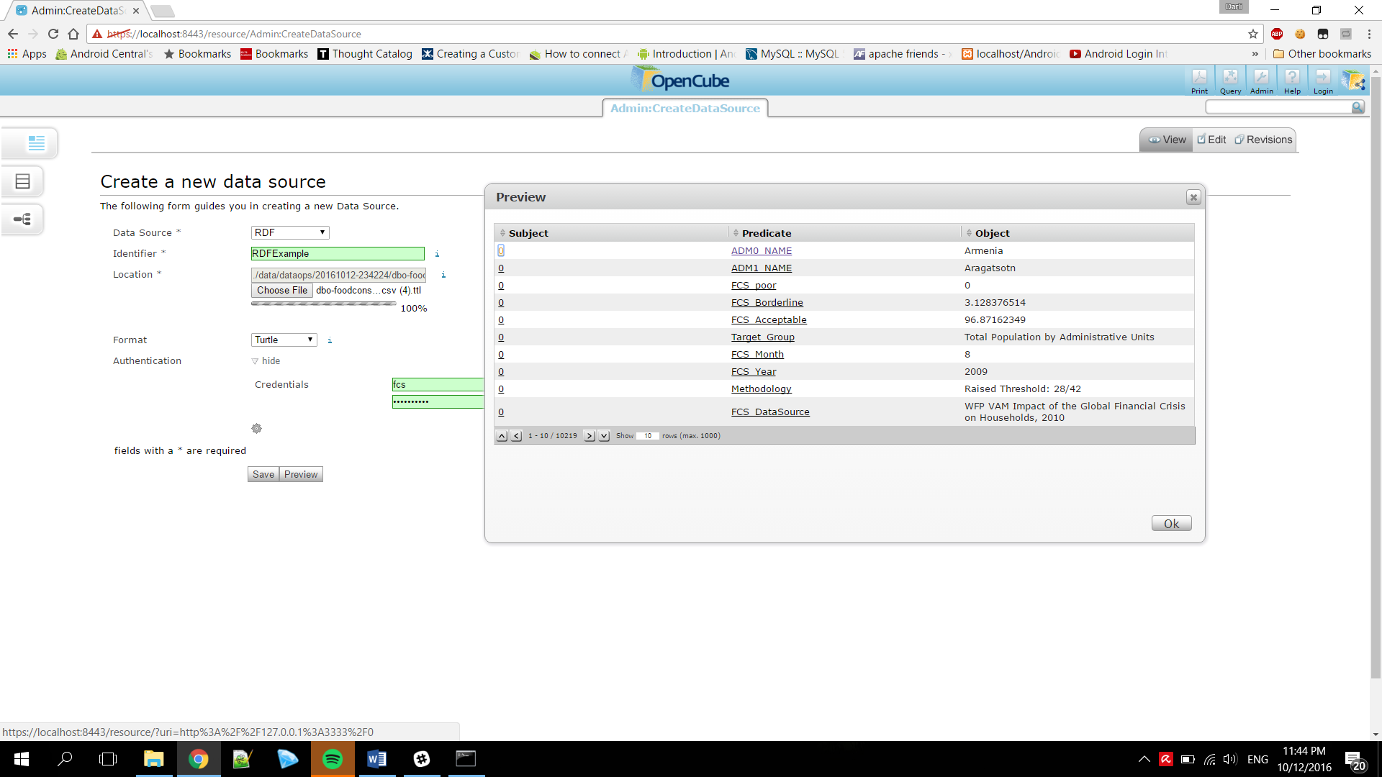

1. Create Data Provider

